**CAR SALES SYSTEM**

**Introduction**

CAR Sales system is a web application which allows user to create and order, edit the order, delete and order also it allows user to attach insurance details to a particular order in car sales system.

**Screens**

CAR Sales system has two main screens like Orders and Insurance Details. Orders screen in turn divided into two sub screens like Order Creation for creating new orders and Order Edit for editing existing orders.

**Order Screen**

The Home screen that is Orders contains two sub screens which are Order creation and Edit Order. In the Order creation events are Click on Order creation tab >> Order creation screen will be opened. The order creation screen will look like given below.

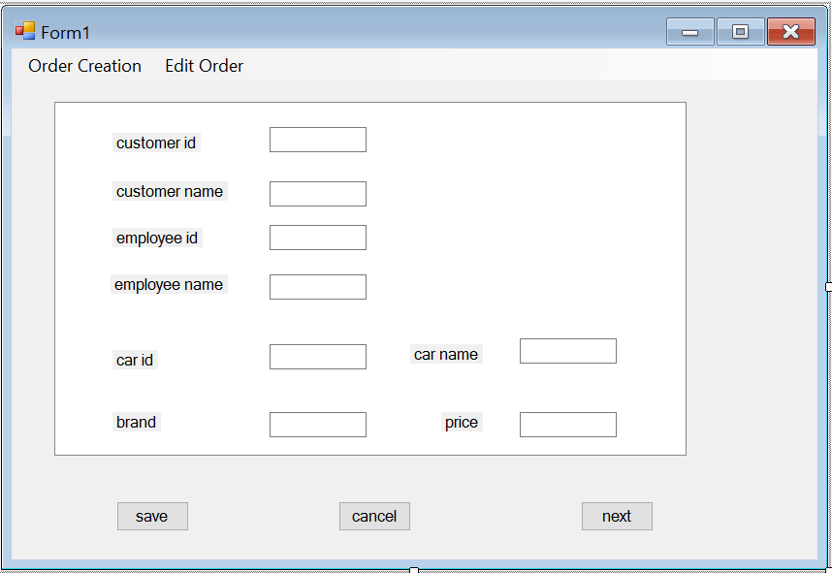

When the user enters the customer name and customer id is loaded and same in the case of employee name, user enters employee name employee id will be loaded.

User then enters Order date, required date. After capturing carid, all the details like brand, name, model, price, engine no, chasis no will be loaded.

User clicks on save, the order id will be generated and all the details will be saved to database.

**Error Messages:**

When user did not capture a mandatory field, then system shall give an error message as shown below.

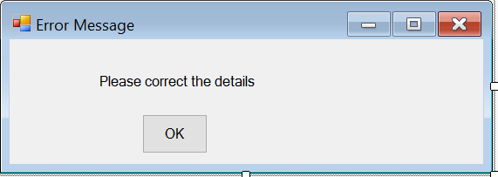

**Editing Order Details:**

Now when user wants to edit the order, then user clicks on edit screen, the below screen will be opened.

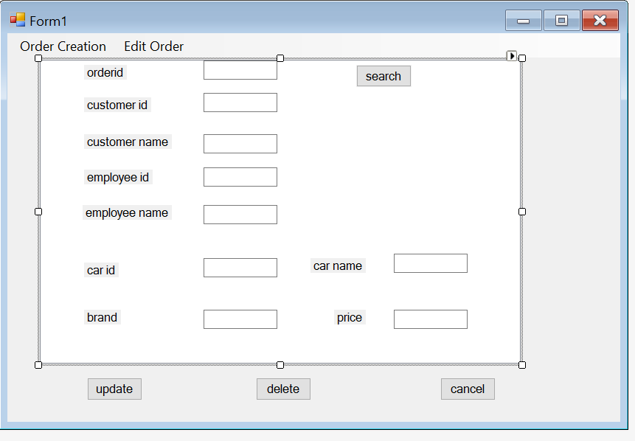

Where the user enters the customer name and clicks on search, then all the details like order id, customer id, employee id, car id etc. will be loaded.

Order id field will be in disabled mode.

User shall edit any field and click on update, the details will be updated.

If the user wants to delete any order, then he/she shall query for the record by entering customer name and click on search, the details will be fetched.

By clicking delete button record shall be deleted.

**Insurance screen:**

This screen will be a child screen in order creation screen, by clicking on Insurance button user will be redirected to below screen to capture insurance details.

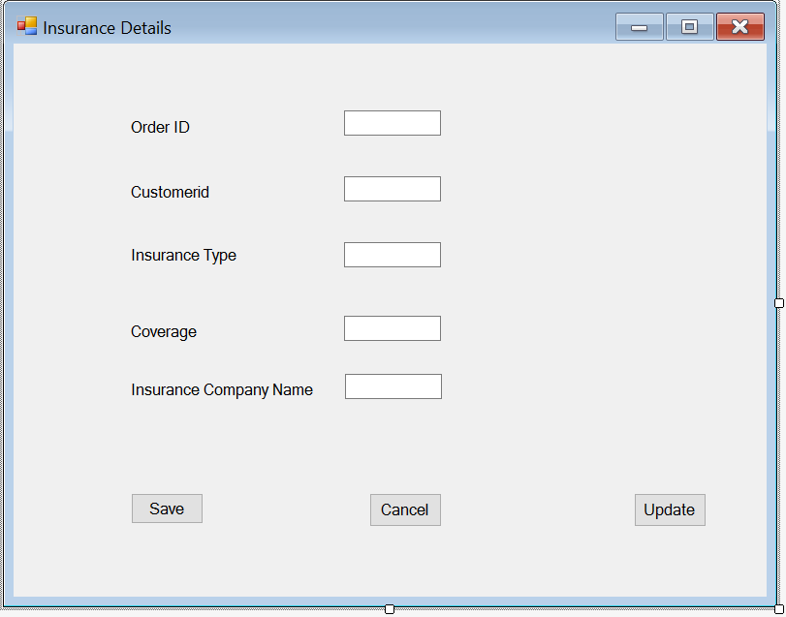

After saving order screen, order id and customer id are loaded in the insurance screen on page load and shall be in disabled mode.

User captures Insurance type which will be a drop down menu and enters the coverage amount and select insurance company name.

Click on Save, details will be saved.

**Editing Insurance details**

If user wants to edit the insurance details, user goes to editing order and enters the customer name, all the details are fetched.

Then user clicks on Insurance tab, insurance details shall be loaded, user then edits the details and clicks on update, Insurance details are updated.

**Error Messages:**

When user did not capture a mandatory field, then system shall give an error message as shown below.

